Tool & Technique Laboratory (T&T Lab.)

[CS-3096]
Individual Work
Lab. No: , Date: , Day:
Topic:
Roll Number: | 20051939 | Branch/Section: | CSE - 17
Name in Capital: | SHASHIKANT SHAH

(Instruction: Rename this file as r-LAB-x where r is your roll number & x is your lab. number & Suppose your roll number is 1905123 & you want to submit lab-2 programs, then file name should be 1905123-LAB-2. Finally delete all texts inside parentheses, also parenthesis)

Program No: (1.)

Program Title:
(WAP to calculate the factorial of a given number)

Input/Output Screenshots:
RUN-1:
(Paste here the screenshots of first run)

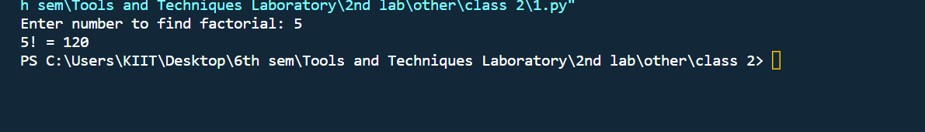

Source code
(Paste here the source code)

n = int(input("Enter number to find factorial: "))
prod = 1
for num in range(1, n + 1):
prod *= num
print(f"{n}! = {prod}")

Conclusion/Observation
Successfully compile to calculate the factorial of a given number

Program No: (2.)

Program Title:
(WAP to calculate the sum of digits of a given number .)
Input/Output Screenshots:
RUN-1:
(Paste here the screenshots of first run)

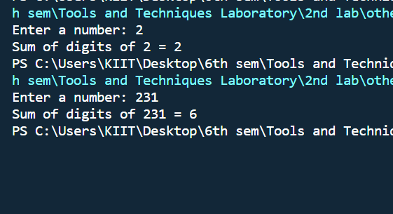
Source code
(Paste here the source code)
# WAP to calculate sum of digits of a number
n = input("Enter a number: ")
sum = 0
for num in n:
sum += ord(num) - ord('0')
print(f"Sum of digits of {n} = {sum}")

Conclusion/Observation
Successfully compile to calculate the sum of digits of a given number

Program No: (3.)

Program Title:
(WAP to display the reverse of a number entered through keyboard.)
Input/Output Screenshots:
RUN-1:
(Paste here the screenshots of first run)
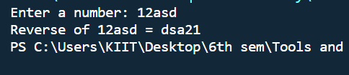

Source code
(Paste here the source code)

n = input("Enter a number: ")
print(f"Reverse of {n} = {n[::-1]}")

Conclusion/Observation
Successfully compile to reverse the string

Program No: (4.)

Program Title:
(WAP to find the GCD/HCF of two number. )

Input/Output Screenshots:
RUN-1:
(Paste here the screenshots of first run)
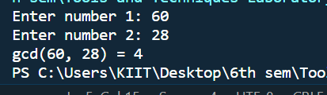

Source code
(Paste here the source code)
a = int(input("Enter number 1: "))
b = int(input("Enter number 2: "))

def gcd(a, b):
if a == 0:
return b
return gcd(b % a, a)

print(f"gcd({a}, {b}) = {gcd(a, b)}")

Conclusion/Observation
Successfully compile to find gcd of two numbers

Program No: (5.)

Program Title:
(# WAP to check if number is prime)

Input/Output Screenshots:
RUN-1:
(Paste here the screenshots of first run)
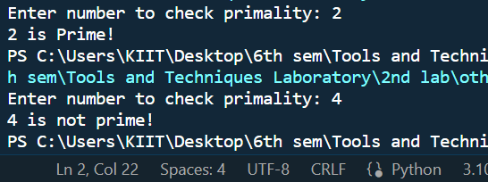

Source code
(Paste here the source code)
from math import sqrt

def isPrime(n):
num = 2
for num in range(2, int(sqrt(n)) + 1):
if n % num == 0:
return False
return True

n = int(input("Enter number to check primality: "))
if isPrime(n):
print(f"{n} is Prime!")
else:
print(f"{n} is not prime!")

Conclusion/Observation
Successfully compile to check if number is prime or not

Program No: (.6)

Program Title:
(# WAP to print all odd and even numbers separately within a given range. The range is input through user. )

Input/Output Screenshots:
RUN-1:
(Paste here the screenshots of first run)
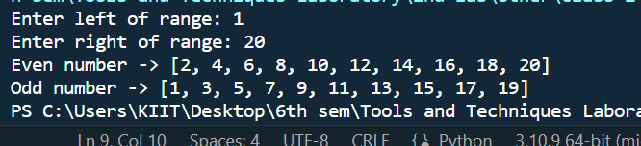
Source code
(Paste here the source code)

# WAP to print all odd and even numbers separately within a given range. The range is input through user.
l = int(input("Enter left of range: "))
r = int(input("Enter right of range: "))
odd = []
even = []
for num in range(l, r + 1):
if num & 1:
odd.append(num)
else:
even.append(num)

print(f"Even number -> {even}")
print(f"Odd number -> {odd}")

Conclusion/Observation
Successfully compile to print all odd and even numbers separately within a given range. The range is input through user.

Program No: (7.)

Program Title:
(# WAP to evaluate the equation y=x^n where n is a non-negative integer)

Input/Output Screenshots:
RUN-1:
(Paste here the screenshots of first run)
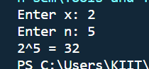

Source code
(Paste here the source code)
x = int(input("Enter x: "))
n = int(input("Enter n: "))
print(f"{x}^{n} = {x**n}")

Conclusion/Observation
Successfully compile to evaluate the equation y=x^n where n is a non-negative integer.

Program No: (.8)

Program Title:
(#WAP to check whether an input integer is perfect number or not. )

Input/Output Screenshots:
RUN-1:
(Paste here the screenshots of first run)
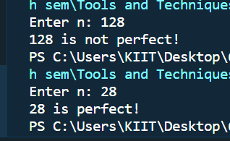
Source code
(Paste here the source code)
# WAP to check whether an input integer is perfect number or not.
n = int(input("Enter n: "))

sum = 0
for num in range(1, n):
if n % num == 0:
sum += num

if sum == n:
print(f"{n} is perfect!")
else:
print(f"{n} is not perfect!")

Conclusion/Observation
Successfully compile to check whether an input integer is perfect number or not.

Program No: (9.)

Program Title:
(#WAP to check whether an input integer is strong number or not. )

Input/Output Screenshots:
RUN-1:
(Paste here the screenshots of first run)
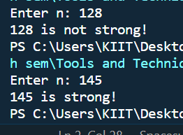
Source code
(Paste here the source code)
# WAP to check whether an input integer is strong number or not.
n = int(input("Enter n: "))

def fac(n):
if n <= 1:
return 1
return n * fac(n - 1)

sum = 0
temp = n
while temp != 0:
sum += fac(temp % 10)
temp //= 10

if sum == n:
print(f"{n} is strong!")
else:
print(f"{n} is not strong!")

Conclusion/Observation
Successfully compile to check whether an input integer is strong number or not

Program No: (10.)

Program Title:
(# WAP to find out the prime factors of a number entered through keyboard (distinct).)

Input/Output Screenshots:
RUN-1:
(Paste here the screenshots of first run)
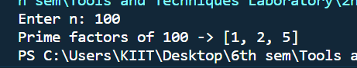
Source code
(Paste here the source code)
# WAP to find out the prime factors of a number entered through keyboard (distinct).
from math import sqrt

n = int(input("Enter n: "))

facs = []

def isPrime(n):
num = 2
for num in range(2, int(sqrt(n)) + 1):
if n % num == 0:
return False
return True

for num in range(1, n + 1):
if isPrime(num) and n % num == 0:
if num in facs:
continue
else:
facs.append(num)

print(f"Prime factors of {n} -> {facs}")

Conclusion/Observation
Successfully compile to find out the prime factors of a number entered through keyboard (distinct

Program No: (11.)

Program Title:
(# WAP to find the first n numbers of a Fibonacci sequence.)

Input/Output Screenshots:
RUN-1:
(Paste here the screenshots of first run)
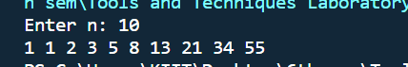
Source code
(Paste here the source code)

# WAP to find the first n numbers of a Fibonacci sequence.
n = int(input("Enter n: "))
f = 1
s = 1
if n == 1:
print('1')
elif n == 2:
print('1 1')
else:
n -= 2
print('1 1', end=' ')
while n != 0:
print(f'{f + s}', end=' ')
sum = f + s
s = f
f = sum
n -= 1

Conclusion/Observation
Successfully compile to find the first n numbers of a Fibonacci sequence.)

Program No: (12.)

Program Title:
(# WAP to print the series as 1 3 7 15 31 ........, where n is given by user.)

Input/Output Screenshots:
RUN-1:
(Paste here the screenshots of first run)
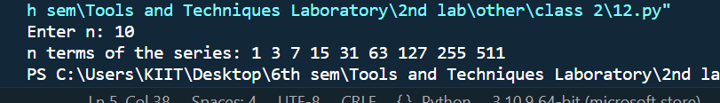
Source code
(Paste here the source code)
# WAP to print the series as 1 3 7 15 31 ........, where n is given by user.
n = int(input("Enter n: "))
print("n terms of the series: ", end='')
for num in range(1, n):
print(f"{2 ** num - 1}", end=' ')

Conclusion/Observation
Successfully compile to the series as 1 3 7 15 31 ........, where n is given by user.

Program No: (13.)

Program Title:
(# WAP to print the series as 3 5 7 11 13 17..........n, where n is given by user )

Input/Output Screenshots:
RUN-1:
(Paste here the screenshots of first run)
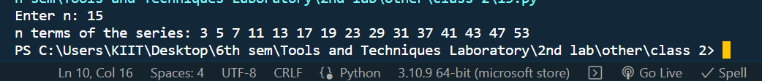
Source code
(Paste here the source code)
# WAP to print the series as 3 5 7 11 13 17..........n, where n is given by user
from math import sqrt
n = int(input("Enter n: "))
series = []
def isPrime(n):
num = 2
for num in range(2, int(sqrt(n)) + 1):
if n % num == 0:
return False
return True
for i in range(2, 1000):
if (i & 1) and isPrime(i):
series.append(i)
print("n terms of the series: ", end='')
for i in range(n):
print(f"{series[i]}", end=' ')

Conclusion/Observation
Successfully compile to the series as 3 5 7 11 13 17..........n, where n is given by user

Program No: (.)

Program Title:
(# WAP to check if number is prime)

Input/Output Screenshots:
RUN-1:
(Paste here the screenshots of first run)

Source code
(Paste here the source code)

Conclusion/Observation
Successfully compile to

Program No: (.)

Program Title:
(# WAP to check if number is prime)

Input/Output Screenshots:
RUN-1:
(Paste here the screenshots of first run)

Source code
(Paste here the source code)

Conclusion/Observation
Successfully compile to

Program No: (.)

Program Title:
(# WAP to check if number is prime)

Input/Output Screenshots:
RUN-1:
(Paste here the screenshots of first run)

Source code
(Paste here the source code)

Conclusion/Observation
Successfully compile to

Program No: (.)

Program Title:
(# WAP to check if number is prime)

Input/Output Screenshots:
RUN-1:
(Paste here the screenshots of first run)

Source code
(Paste here the source code)

Conclusion/Observation
Successfully compile to

Program No: (.)

Program Title:
(# WAP to check if number is prime)

Input/Output Screenshots:
RUN-1:
(Paste here the screenshots of first run)

Source code
(Paste here the source code)

Conclusion/Observation
Successfully compile to

Program No: (.)

Program Title:
(# WAP to check if number is prime)

Input/Output Screenshots:
RUN-1:
(Paste here the screenshots of first run)

Source code
(Paste here the source code)

Conclusion/Observation
Successfully compile to

